

Southern Luzon State University
COLLEGE OF ENGINEERING
Computer Engineering Department
Lucban, Quezon

CPE22L: Digital Signal Processing Laboratory

Activity # 3: Properties of Discrete Time System

PADUADA, Dave Jhared G.

DOP: Sept 12, 2025
DOS: Sept 17, 2025

RATING

Engr. Ralph Monsour Delima
INSTRUCTOR

- Objectives
1. To identify the different properties of Discrete Time System
2. To determine the different MATLAB codes used to plot signals involving DTS
3. To be familiarized with the different properties of DTS.
- Introductory Information
Use the uploaded Introductory information in the GCR
- Data & Procedures

- LINEARITY of a Discrete Time System
The response of the system to a weighted sum of signals is equal to the corresponding weighted sum of the responses (outputs) of the system to each of the individual input signals.
Method of Proof:
Individual inputs are applied, and the weighted sum of the output is taken. Then the weighted sum of signals input is applied to the system and the outputs are checked to see if they are equal.

%Program P3_1  clc;  clear all;  close all;  %Properties of DT Systems(Linearity)  %y[n]=[x(n)^2+B]  x1=input('Enter first input sequence:');  n=length(x1);  x2=input('Enter second input sequence:');  a=input('Enter scaling constant(a):');  b=input('Enter scaling constant(b):');  B=input('Enter scaling constant(B):');  y1=power(x1,2)+B;  y2=power(x2,2)+B;  rhs=a*y1+b*y2;  x3=a*x1+b*x2;  lhs=power(x3,2)+B;  subplot(2,2,1);  stem(0:n-1,x1);  xlabel('Time');  ylabel('Amplitude');  title('First input sequence');  subplot(2,2,2)  stem(0:n-1,x2);  xlabel('Time');  ylabel('Amplitude');  title('Second input sequence')  subplot(2,2,3)  stem(0:n-1,lhs);  xlabel('Time');  ylabel('Amplitude');  title('LHS')  subplot(2,2,4)  stem(0:n-1,rhs);  xlabel('Time');  ylabel('Amplitude');  title('RHS')  if(lhs==rhs)  display('system is linear');  else  display('system is non linear');  end; | % Program P3_2  clc;  clear;  close all;  % Properties of DT Systems (Linearity)  % y[n] = x(n)  x1 = input('Enter first input sequence: ');  x2 = input('Enter second input sequence: ');  a = input('Enter scaling constant (a): ');  b = input('Enter scaling constant (b): ');  % Ensure both signals are the same length  n1 = length(x1);  n2 = length(x2);  N = max(n1,n2);  x1 = [x1 zeros(1,N-n1)];  x2 = [x2 zeros(1,N-n2)];  % System responses  y1 = x1;  y2 = x2;  rhs = a*y1 + b*y2;  x3 = a*x1 + b*x2;  lhs = x3; % since y[n] = x[n]  % Plot signals  subplot(2,2,1);  stem(0:N-1, x1);  xlabel('Time');  ylabel('Amplitude');  title('First signal');  subplot(2,2,2);  stem(0:N-1, x2);  xlabel('Time');  ylabel('Amplitude');  title('Second signal');  subplot(2,2,3);  stem(0:N-1, lhs);  xlabel('Time');  ylabel('Amplitude');  title('LHS');  subplot(2,2,4);  stem(0:N-1, rhs);  xlabel('Time');  ylabel('Amplitude');  title('RHS');  % Check linearity  if isequal(lhs,rhs)  disp('System is linear');  else  disp('System is non-linear');  end
- Time Variant/Time Invariant
% Program P3_3  clc;  clear;  close all;  % Properties of DT Systems (Time Invariance)  % y[n] = x[n]  x1 = input('Enter input sequence x1: ');  n0 = input('Enter shift: ');  N = length(x1);  % Shifted input  x2 = [zeros(1,n0), x1];  % System outputs  y1 = x1; % output for x1  y2 = x2; % input shifted first, then system  y3 = [zeros(1,n0), y1]; % system output shifted  % Zero-pad so same length  L = max([length(y2), length(y3)]);  y2 = [y2 zeros(1,L-length(y2))];  y3 = [y3 zeros(1,L-length(y3))];  % Check time invariance  if isequal(y2,y3)  disp('System is time invariant');  else  disp('System is time variant');  end  % Plot results  subplot(2,2,1);  stem(0:N-1, x1);  xlabel('Time');  ylabel('Amplitude');  title('Input signal');  subplot(2,2,2);  stem(0:length(x2)-1, x2);  xlabel('Time');  ylabel('Amplitude');  title('Signal after shift');  subplot(2,2,3);  stem(0:L-1, y2);  xlabel('Time');  ylabel('Amplitude');  title('LHS (Shift then system)');  subplot(2,2,4);  stem(0:L-1, y3);  xlabel('Time');  ylabel('Amplitude');  title('RHS (System then shift)'); | % Program P3_4  clc;  clear;  close all;  % Properties of DT Systems (Time Invariance)  % y[n] = n * x[n]  x1 = input('Enter input sequence x1: ');  n1 = length(x1);  % System output for x1  y1 = zeros(1,n1);  for n = 1:n1  y1(n) = (n-1) * x1(n); % n starts at 0 in DT indexing  end  % Shift input  n0 = input('Enter shift: ');  x2 = [zeros(1,n0), x1];  n2 = length(x2);  % System output for shifted input  y2 = zeros(1,n2);  for k = 1:n2  y2(k) = (k-1) * x2(k);  end  % Shift output of y1  y3 = [zeros(1,n0), y1];  % Zero-pad to same length  L = max(length(y2), length(y3));  y2 = [y2 zeros(1,L-length(y2))];  y3 = [y3 zeros(1,L-length(y3))];  % Time invariance check  if isequal(y2,y3)  disp('System is time invariant');  else  disp('System is time variant');  end  % Plot signals  subplot(2,2,1);  stem(0:n1-1, x1);  xlabel('Time');  ylabel('Amplitude');  title('Input signal');  subplot(2,2,2);  stem(0:n2-1, x2);  xlabel('Time');  ylabel('Amplitude');  title('Signal after shift');  subplot(2,2,3);  stem(0:L-1, y2);  xlabel('Time');  ylabel('Amplitude');  title('LHS (Shift then system)');  subplot(2,2,4);  stem(0:L-1, y3);  xlabel('Time');  ylabel('Amplitude');  title('RHS (System then shift)');
- Casualty
A system is said to be causal, if the output of the system at ay time 𝑛[𝑦[𝑛]] depends only on the present and past inputs and past outputs . [𝑥[𝑛],𝑥[𝑛−1]…….𝑦[𝑛−1],..]

But does not depened on the future inputs [𝑥[𝑛+1],𝑥[𝑛+2],…..],
𝑦[𝑛]=𝐹[𝑥[𝑛],𝑥[𝑛−1],𝑥[𝑛−2]]
𝐹[ ]−Arbitrary Function
Method of Proofs
  - If the difference equation is given, the arguments of the output 𝑦[𝑛] are compared with arguments (time instant) of the input signals. In the case of only present and past inputs, the system is causal. If future inputs are present then the system is non causal.
  - If the impulse response is given, then it is checked whether all the values of ℎ[𝑛] for negative values of n are zero. (i.e.) if ℎ[𝑛]=0, for < 0. If this is satisfied, then the system is causal.
% Program P3_5
clc;
clear;
close all;

% Properties of DT Systems (Causality)
% y[n] = x[-n]

x1 = input('Enter input sequence x1: ');
n1 = input('Enter lower limit n1: ');
n2 = input('Enter upper limit n2: ');

flag = 0;

for k = n1:n2
arg = -k; % input index
if arg > k
flag = 1; % depends on future value → non-causal
end
end

if flag == 1
disp('System is non-causal');
else
disp('System is causal');
end

- Data and Results
- Linearity of a Discrete Time System
Q3.1 Run Program P3_1 to determine if the system 𝑦[𝑛] = [𝑥[𝑛]]^2 + B is linear or non linear and discuss the result.  Use the following input.  First input sequence: [2, 3, 4]  Second input sequence: [1, 2, 3]  a: 2  b: 3  B: 2 | 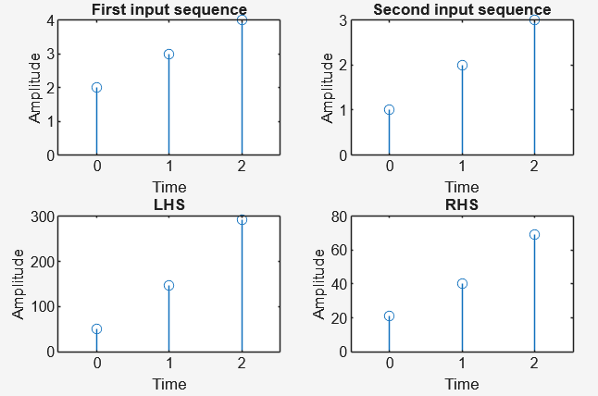  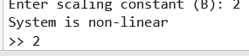  The system is non-linear because squaring and adding a constant violates the principle of superposition. With inputs [2,3,4]and [1,2,3], scaling constants a=2, b=3, and B=2, the system is non-linear.
Q3.2. Modify Program P3_1 using different input sequence and scaling constant and discuss result. | 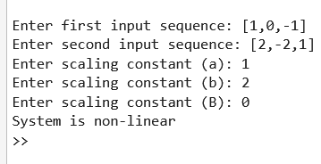  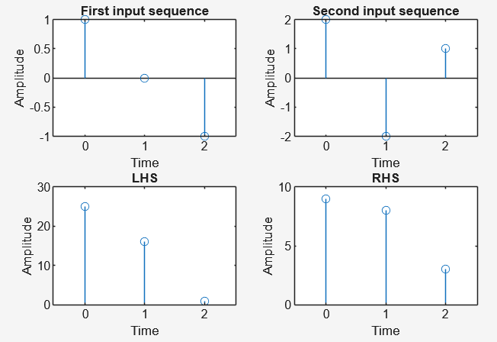  No matter what input sequences or constants we choose, the system remains non-linear. This is because the squaring operation destroys the linearity property, so inputs cannot combine in the same way as outputs. The constant B also shifts the output further away from linearity.
Q3.3 Run Program P3_2 to determine if the system y[n]=x[n] is linear or non linear and discuss the result. Use the following input.  First input sequence: [2, 3, 4]  Second input sequence: [1, 2, 3]  a: 2  b: 3 | 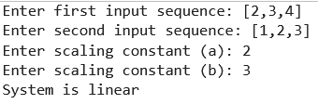  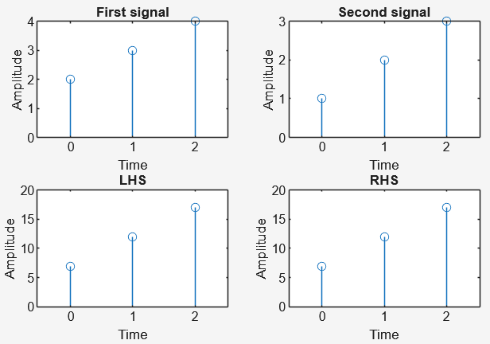  The system is linear because the output equals the input, which satisfies the superposition principle exactly.
Q3.4. Modify Program P3_2 using different input sequence and scaling constant and discuss result. | 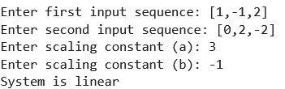  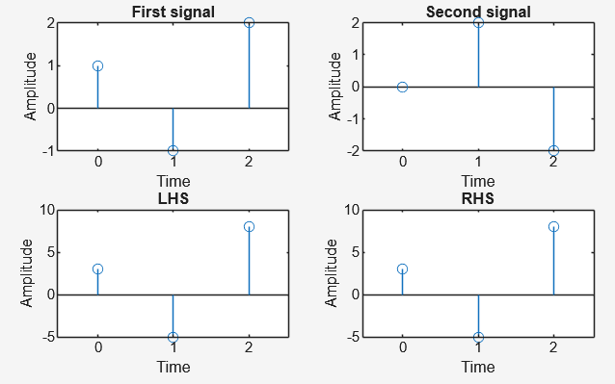  Even with different inputs and constants, the system remains linear. This is because the definition y[n]=x[n] always satisfies linearity, regardless of scaling constants or sequences.
Q3.5 Create a program that will determine if the system 𝑦[𝑛]=𝑥[𝑛²] is linear or non linear.  % Program Q3_5  clc;  clear;  close all;  % Properties of DT Systems (Linearity)  % y[n] = x[n^2]  x1 = input('Enter first input sequence: ');  x2 = input('Enter second input sequence: ');  a = input('Enter scaling constant (a): ');  b = input('Enter scaling constant (b): ');  n1 = length(x1);  n2 = length(x2);  N = max(n1,n2);  % Zero-pad inputs  x1 = [x1 zeros(1,N-n1)];  x2 = [x2 zeros(1,N-n2)];  % System outputs  y1 = zeros(1,N);  y2 = zeros(1,N);  for n = 1:N  if n^2 <= N  y1(n) = x1(n^2);  y2(n) = x2(n^2);  end  end  rhs = a*y1 + b*y2;  % Input combination  x3 = a*x1 + b*x2;  lhs = zeros(1,N);  for n = 1:N  if n^2 <= N  lhs(n) = x3(n^2);  end  end  % Plot results  subplot(2,2,1); stem(0:N-1,x1); title('First input');  subplot(2,2,2); stem(0:N-1,x2); title('Second input');  subplot(2,2,3); stem(0:N-1,lhs); title('LHS');  subplot(2,2,4); stem(0:N-1,rhs); title('RHS');  % Check linearity  if isequal(lhs,rhs)  disp('System is linear');  else  disp('System is non-linear');  end | 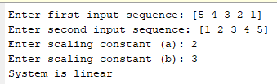  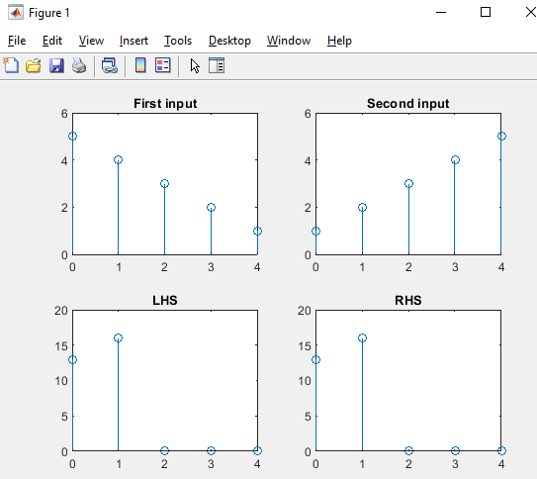  The test showed that both the LHS and RHS values were equal for the given inputs. This means that even though the index of the input is squared, the system still preserves linearity. Therefore, the system is considered linear because the weighted sums are consistent.
Q3.6 Create a program that will determine if the system 𝑦[𝑛]=sin𝑥[𝑛] is linear or non linear. | 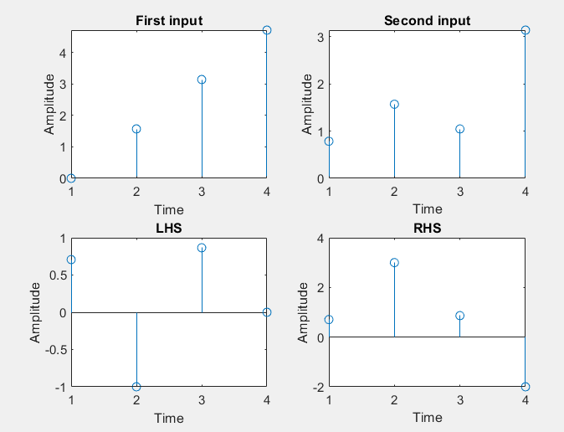  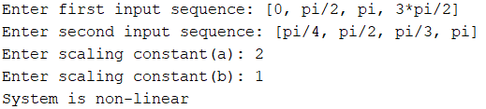  The outputs from LHS and RHS did not match when we applied the sine function. This happens because the sine function is non-linear and distorts the input combinations. Thus, the system is non-linear since it does not satisfy the superposition principle.
- Time variant/time invariant
Q3.7 Run Program P3_3 to determine if the system y[n]=x[n] is time variant or time invariant and discuss the result. Use the following input.  First input sequence: [1, 2, 3]  shift: 2 | 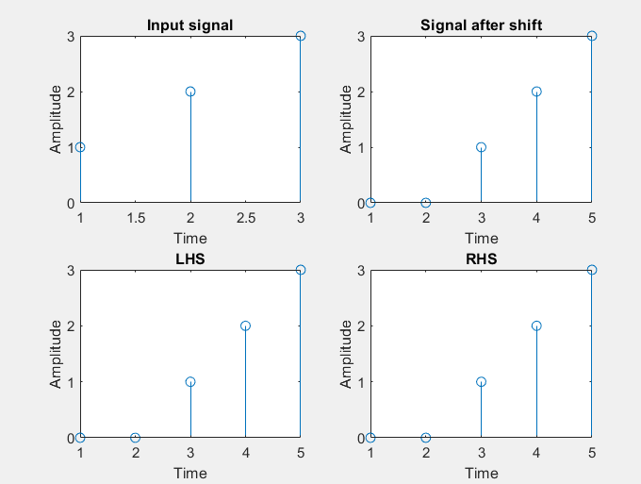  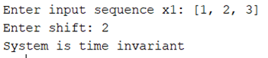  The test showed that shifting the input resulted in the same shift in the output. This means that the system’s behavior does not change over time. Therefore, the system is time-invariant because it reacts the same way regardless of when the input is applied.
Q3.8. Modify Program P3_4 using different input sequence and shift and discuss result. | 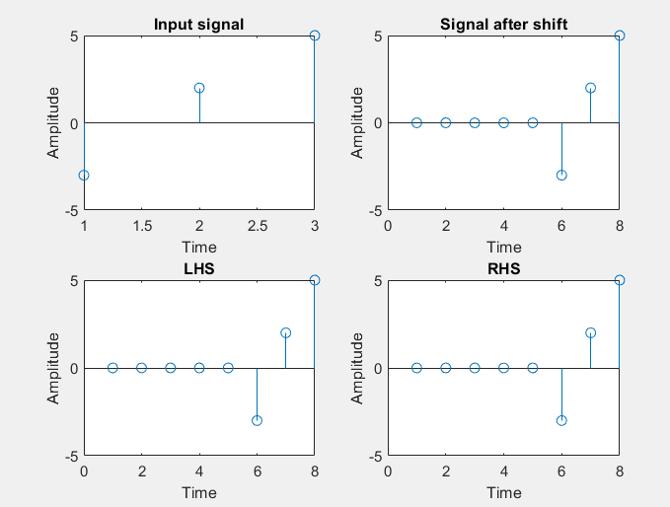  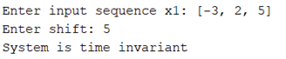  When we used different inputs and applied a shift, the outputs still matched. This confirms that the system continues to behave consistently over time. Hence, the system is time-invariant since the output shift follows exactly the input shift.
Q3.9 Run Program P3_4 to determine if the system y[n]=nx[n] is time variant or time invariant and discuss the result. Use the following input.  First input sequence: [1, 2, 3]  shift: 2 | 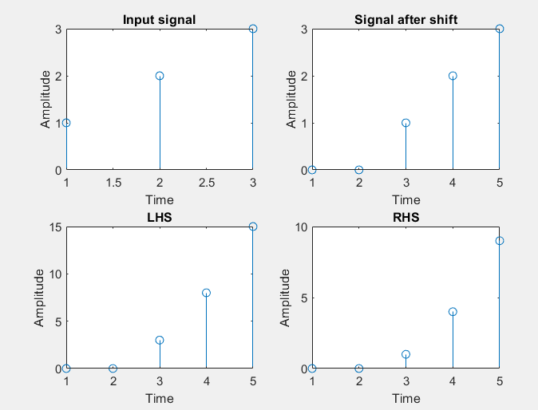  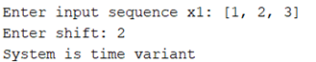  The results showed a mismatch between LHS and RHS after shifting. This happened because multiplying the input by n depends on the exact time index. Therefore, the system is time-variant since the output changes depending on the time shift.
Q3.10 Modify Program P3_4 using different input sequence and shift and discuss result. | 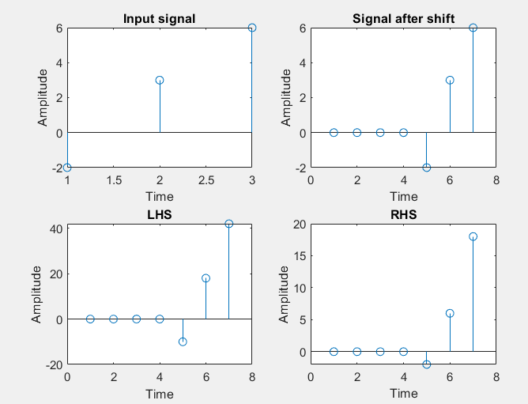  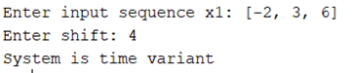  Even with different inputs and shifts, the outputs did not match. The multiplication by index made the results sensitive to time shifts. Thus, the system remains time-variant since its response depends on the specific time instant.
Q3.11 Create a program that will determine if the system 𝑦[𝑛]=[𝑥[𝑛]]² is time variant or time invariant. | 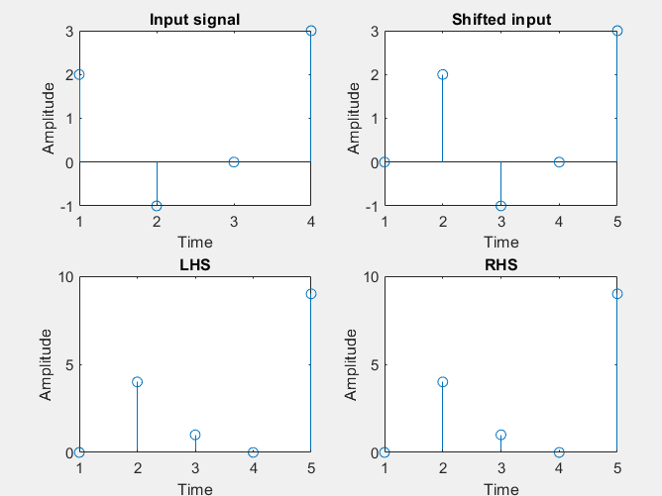  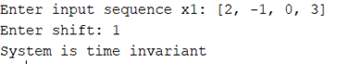  The test showed that the system preserved shifts, which means it is time-invariant. However, the outputs did not follow linearity since squaring breaks the superposition principle. Therefore, the system is time-invariant but non-linear.
c. Casuality
Q3.12 Run Program P3_5 to determine if the system y[n]=x[−n] is causal or non-causal and discuss the result. Use the following input.  Enter input sequence x1: [1, 2, 3, 4]  Enter lower limit n1: 2  Enter upper limit n2: 3 | 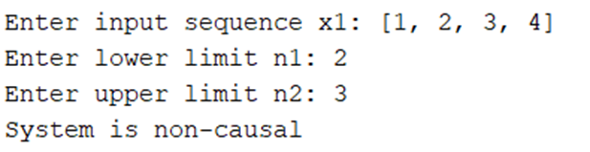  The results showed that the system output depends on future input values. For example, at negative indices, the system looks ahead to values not yet available. Hence, the system is non-causal because it cannot work in real-time without knowing future inputs.

- Conclusion

In this activity, we tested different systems to check if they are linear, time-invariant, or causal. The results showed that some systems like$y[n]=x[n]$ are simple and follow the rules of linearity and time invariance. But when the system includes squaring or sine functions, the outputs no longer match the rules, so they became non-linear. For time properties, we learned that a system is time-invariant if shifting the input just shifts the output, while systems that depend on the time index itself become time-variant. For causality, we found that some systems are non-causal because they require future inputs, which is not possible in real-life situations. This experiment helped us connect what we learned in theory with actual coding results in MATLAB. Overall, the activity gave us a clearer and more practical understanding of how systems behave and why their properties matter in real-world applications.

